**MATHS WORKSHEET DATE :**

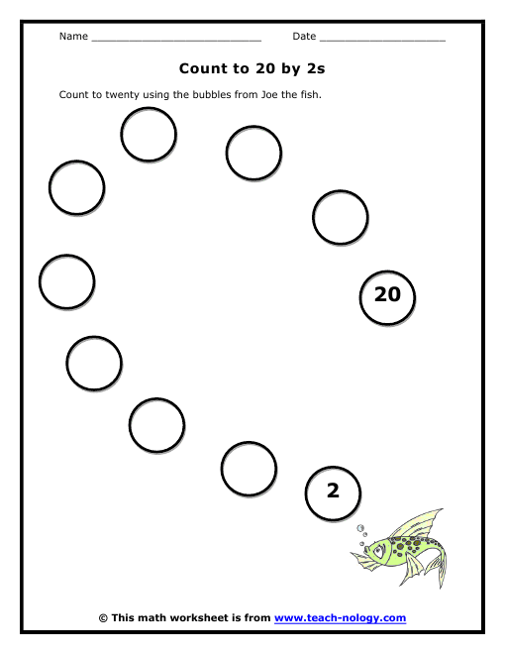 **WRITE THE NUMBER NAMES 1-10**

|  |
| --- |
|  |
|  |
|  |
|  |
|  |
|  |
|  |
|  |
|  |
|  |

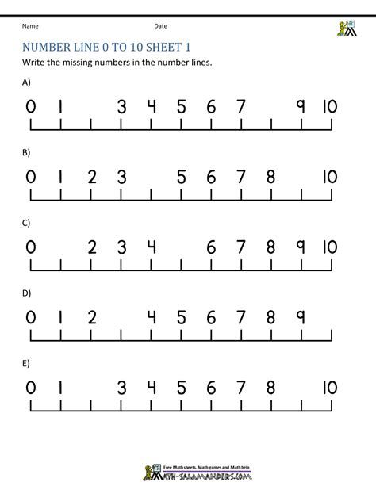

**COUNT AND WRITE THE NUMBERS**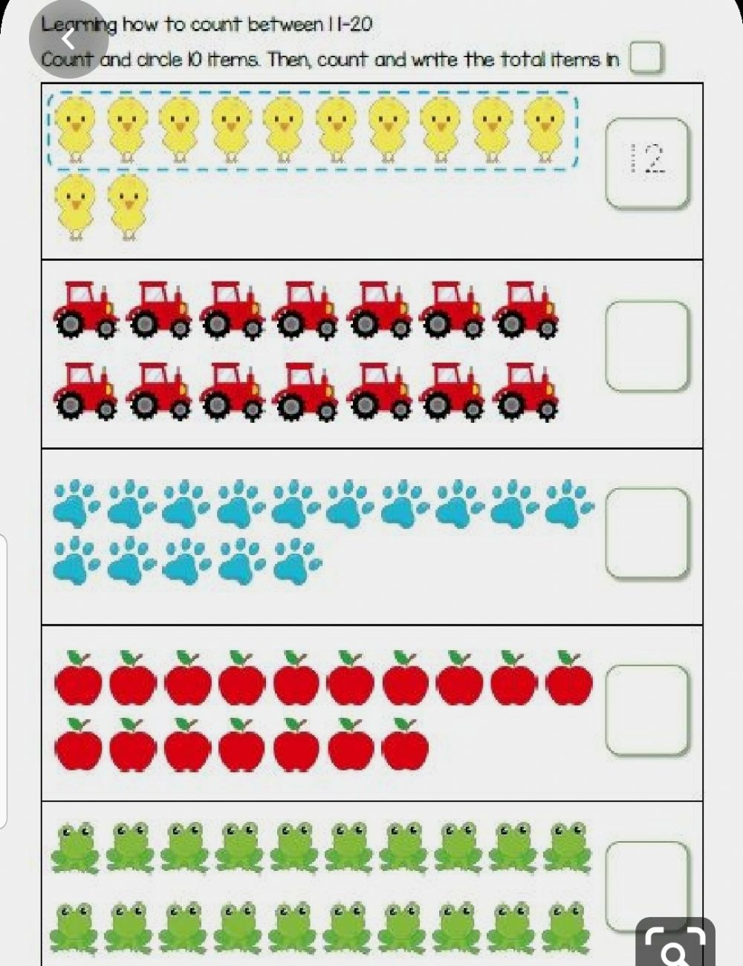

**WRITE FULL FOR (F) AND EMPTY FOR (E)**

